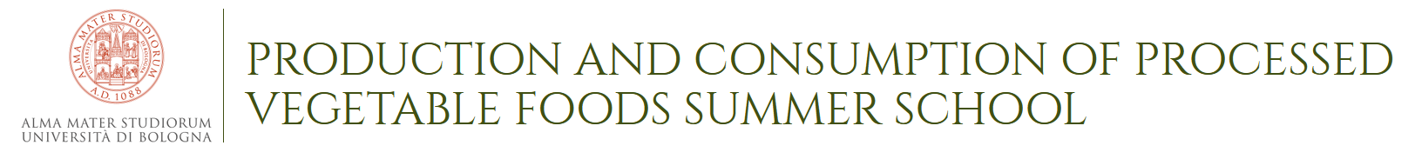

ENROLLMENT FORM
fill out the form and send it along with the required attachments to: giulia.baldi4@unibo.it
FIRST NAME
SURNAME
GENDER
PLACE AND DATE OF BIRTH
NATIONALITY
STREET
POSTAL CODE
CITY
COUNTRY
DEGREE OBTAINED
PHD STUDENT IN
UNIVERSITY
E-MAIL
PHONE NUMBER
By filling this form you consent to the processing of personal information in accordance with article 13 of European regulation 2016/679 (GDPR) for the processing of data collected through web browsing.

The registration fee is of 250€ (VAT included) and it includes:

- Welcome buffet on day of arrival (June 25th)
- Access to sessions
- Participant materials
- Lunches and coffee breaks as per program
- 1 canteen dinner (June 26th)
- 2 dinner voucher (June 27th e 28th)
- Social dinner (June 29th)
- Double room accommodation for 5 nights (from June 25th to June 30th)

Required attachments:
- Curriculum vitae
- Motivational letter (in English)
- Certification of graduation with exams and grades
- Certification or self-certification of knowledge of the English language
- A front-back copy of a valid identification document
- A front-back copy of the Tax Code (if in possession)
- Reference letter

